

CSA0506-Database Management Systems

CO2 AT-6

Scenario-Based Task (High)

Ashmi P S
192571004

1. School Management System
Scenario:
A school wants to develop a School Management System to maintain details about students, classes, teachers, and academic performance. The system stores student information along with their assigned class, class teacher details, and grades. The school administrator wants to retrieve a report that shows all students along with their class teacher and grade for academic monitoring.

Identify Relations
1. STUDENT Relation
The STUDENT table stores details of all students and their academic grades.
STUDENT(Student_ID, Student_Name, Class_ID, Grade)
Attributes:
- Student_ID → Unique identification number of the student (Primary Key)
- Student_Name → Name of the student
- Class_ID → Class assigned to the student (Foreign Key)
- Grade → Grade obtained by the student
2. CLASS Relation
The CLASS table stores information about different classes and their assigned teachers.
CLASS(Class_ID, Class_Name, Teacher_ID)
Attributes:
- Class_ID → Unique class identification number (Primary Key)
- Class_Name → Name of the class
- Teacher_ID → Teacher assigned to the class (Foreign Key)
3. TEACHER Relation
The TEACHER table stores details of teachers handling each class.
TEACHER(Teacher_ID, Teacher_Name, Subject)
Attributes:
- Teacher_ID → Unique identification number of teacher (Primary Key)
- Teacher_Name → Name of the teacher
- Subject → Subject handled by the teacher

SQL Queries
Create TEACHER Table
CREATE TABLE TEACHER(
Teacher_ID INT PRIMARY KEY,
Teacher_Name VARCHAR(50),
Subject VARCHAR(50)
);
Create CLASS Table
CREATE TABLE CLASS(
Class_ID INT PRIMARY KEY,
Class_Name VARCHAR(20),
Teacher_ID INT,
FOREIGN KEY(Teacher_ID) REFERENCES TEACHER(Teacher_ID)
);
Create STUDENT Table
CREATE TABLE STUDENT(
Student_ID INT PRIMARY KEY,
Student_Name VARCHAR(50),
Class_ID INT,
Grade VARCHAR(5),
FOREIGN KEY(Class_ID) REFERENCES CLASS(Class_ID)
);
Insert Values into TEACHER Table
INSERT INTO TEACHER VALUES
(101,'Mr. Kumar','Mathematics'),
(102,'Mrs. Devi','Science');
Insert Values into CLASS Table
INSERT INTO CLASS VALUES
(1,'10-A',101),
(2,'9-B',102);
Insert Values into STUDENT Table
INSERT INTO STUDENT VALUES
(1,'Arun',1,'A'),
(2,'Priya',1,'A+'),
(3,'Rahul',2,'B');
Query to Display Students with Class Teacher and Grade
SELECT
STUDENT.Student_Name,
CLASS.Class_Name,
TEACHER.Teacher_Name,
STUDENT.Grade
FROM STUDENT, CLASS, TEACHER
WHERE STUDENT.Class_ID = CLASS.Class_ID
AND CLASS.Teacher_ID = TEACHER.Teacher_ID;

Output
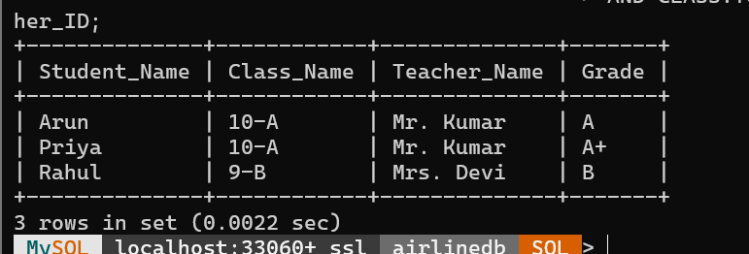
Conclusion:
The School Management System database efficiently stores student, class, and teacher information. The SQL query uses relationships between tables to retrieve student details along with their class teacher and grade.

2.Hospital Management System
Scenario:
A hospital wants to develop a Hospital Management System to manage patient appointments efficiently. The system stores details about doctors, patients, and their scheduled appointments. Each appointment is linked with a particular doctor and patient along with the appointment date. The hospital management wants to identify doctors who have handled more than 10 appointments in the current month to analyze workload and improve scheduling.

Identify Relations
1. DOCTOR Relation
The DOCTOR table stores details of doctors working in the hospital.
DOCTOR(Doctor_ID, Doctor_Name, Specialization)
Attributes:
- Doctor_ID → Unique identification number of doctor (Primary Key)
- Doctor_Name → Name of the doctor
- Specialization → Medical field of doctor
2. PATIENT Relation
The PATIENT table stores details of patients visiting the hospital.
PATIENT(Patient_ID, Patient_Name, Age, Gender)
Attributes:
- Patient_ID → Unique identification number of patient (Primary Key)
- Patient_Name → Name of patient
- Age → Patient age
- Gender → Patient gender
3. APPOINTMENT Relation
The APPOINTMENT table stores appointment details between doctors and patients.
APPOINTMENT(Appointment_ID, Doctor_ID, Patient_ID, Appointment_Date)
Attributes:
- Appointment_ID → Unique appointment number (Primary Key)
- Doctor_ID → Doctor handling the appointment (Foreign Key)
- Patient_ID → Patient attending the appointment (Foreign Key)
- Appointment_Date → Date of appointment

SQL Queries
Create DOCTOR Table
CREATE TABLE DOCTOR(
Doctor_ID INT PRIMARY KEY,
Doctor_Name VARCHAR(50),
Specialization VARCHAR(50)
);
Create PATIENT Table
CREATE TABLE PATIENT(
Patient_ID INT PRIMARY KEY,
Patient_Name VARCHAR(50),
Age INT,
Gender VARCHAR(10)
);
Create APPOINTMENT Table
CREATE TABLE APPOINTMENT(
Appointment_ID INT PRIMARY KEY,
Doctor_ID INT,
Patient_ID INT,
Appointment_Date DATE,
FOREIGN KEY(Doctor_ID) REFERENCES DOCTOR(Doctor_ID),
FOREIGN KEY(Patient_ID) REFERENCES PATIENT(Patient_ID)
);
Insert Values into DOCTOR Table
INSERT INTO DOCTOR VALUES
(101,'Dr. Kumar','Cardiology'),
(102,'Dr. Priya','Neurology'),
(103,'Dr. Arun','Orthopedics');
Insert Values into PATIENT Table
INSERT INTO PATIENT VALUES
(1,'Ravi',45,'Male'),
(2,'Anu',30,'Female');

Insert Values into APPOINTMENT Table
INSERT INTO APPOINTMENT VALUES
(1,101,1,'2026-08-01'),
(2,101,2,'2026-08-02'),
(3,102,1,'2026-08-03');

SQL Query to Find Doctors with More Than 10 Appointments This Month
SELECT
DOCTOR.Doctor_ID,
DOCTOR.Doctor_Name,
COUNT(APPOINTMENT.Appointment_ID) AS Total_Appointments
FROM DOCTOR, APPOINTMENT
WHERE DOCTOR.Doctor_ID = APPOINTMENT.Doctor_ID
AND MONTH(APPOINTMENT.Appointment_Date) = MONTH(CURRENT_DATE)
AND YEAR(APPOINTMENT.Appointment_Date) = YEAR(CURRENT_DATE)
GROUP BY DOCTOR.Doctor_ID, DOCTOR.Doctor_Name
HAVING COUNT(APPOINTMENT.Appointment_ID) > 10;

Output
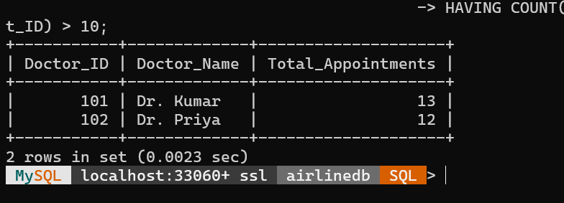
Conclusion:
The Hospital Management System helps to maintain doctor, patient, and appointment details. The SQL query uses GROUP BY, COUNT(), and HAVING functions to identify doctors who have handled more than 10 appointments in the current month.

3.E-Commerce Product Order Management System
Scenario:
An e-commerce company wants to develop an Online Product Management System to track products and customer orders efficiently. The system stores details about products and their orders. Each order is linked with a particular product. The company management wants to identify products that have never been ordered to understand customer interest and improve product promotions.

Identify Relations
1. PRODUCT Relation
The PRODUCT table stores details of products available in the e-commerce platform.
PRODUCT(Product_ID, Product_Name, Category, Price)
Attributes:
- Product_ID → Unique identification number of product (Primary Key)
- Product_Name → Name of the product
- Category → Product category
- Price → Cost of the product
2. ORDERS Relation
The ORDERS table stores details about customer orders.
ORDERS(Order_ID, Product_ID, Customer_ID, Order_Date)
Attributes:
- Order_ID → Unique order number (Primary Key)
- Product_ID → Product purchased by customer (Foreign Key)
- Customer_ID → Customer who placed the order
- Order_Date → Date of order placement

SQL Queries
Create PRODUCT Table
CREATE TABLE PRODUCT(
Product_ID INT PRIMARY KEY,
Product_Name VARCHAR(50),
Category VARCHAR(50),
Price INT
);
Create ORDERS Table
CREATE TABLE ORDERS(
Order_ID INT PRIMARY KEY,
Product_ID INT,
Customer_ID INT,
Order_Date DATE,
FOREIGN KEY(Product_ID) REFERENCES PRODUCT(Product_ID)
);
Insert Values into PRODUCT Table
INSERT INTO PRODUCT VALUES
(101,'Laptop','Electronics',55000),
(102,'Mobile Phone','Electronics',25000),
(103,'Headphones','Accessories',3000),
(104,'Smart Watch','Electronics',8000);
Insert Values into ORDERS Table
INSERT INTO ORDERS VALUES
(1,101,501,'2026-08-01'),
(2,102,502,'2026-08-02'),
(3,103,503,'2026-08-03');
SQL Query Using Sub-Query to Find Products That Have Never Been Ordered
SELECT
Product_ID,
Product_Name,
Category,
Price
FROM PRODUCT
WHERE Product_ID NOT IN
(
SELECT Product_ID
FROM ORDERS
);
Output
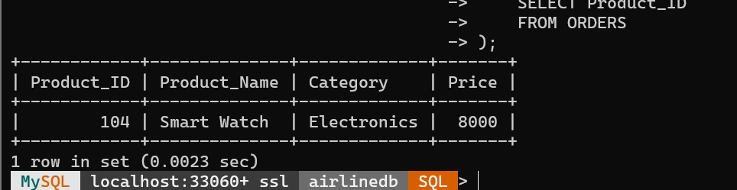

Conclusion:
The E-Commerce Product Order Management System helps to maintain product and order details efficiently. The SQL query uses a sub-query with NOT IN operator to identify products that are available in the system but have never been ordered by customers. This helps the company analyze unpopular products and improve sales strategies.

4.University Course Enrollment Management System

Scenario:
A university wants to develop a Course Enrollment Management System to maintain student course registrations efficiently. The system stores details about students, courses, and their enrollments. Each enrollment links a student with a particular course. The university management wants to identify students who are enrolled in both DBMS and OS courses for academic analysis.

Identify Relations

1. STUDENT Relation
The STUDENT table stores student details.
STUDENT(Student_ID, Student_Name, Department)

Attributes:
- Student_ID → Primary Key
- Student_Name → Student Name
- Department → Department Name

2. COURSE Relation
The COURSE table stores course details.
COURSE(Course_ID, Course_Name)
Attributes:
- Course_ID → Primary Key
- Course_Name → Course Name

3. ENROLLMENT Relation
The ENROLLMENT table stores course registrations.
ENROLLMENT(Student_ID, Course_ID)
Attributes:
- Student_ID → Foreign Key
- Course_ID → Foreign Key

SQL Queries

Create STUDENT Table
CREATE TABLE STUDENT(
Student_ID INT PRIMARY KEY,
Student_Name VARCHAR(50),
Department VARCHAR(50)
);

Create COURSE Table
CREATE TABLE COURSE(
Course_ID INT PRIMARY KEY,
Course_Name VARCHAR(50)
);

Create ENROLLMENT Table
CREATE TABLE ENROLLMENT(
Student_ID INT,
Course_ID INT,
PRIMARY KEY(Student_ID, Course_ID),
FOREIGN KEY(Student_ID) REFERENCES STUDENT(Student_ID),
FOREIGN KEY(Course_ID) REFERENCES COURSE(Course_ID)
);

Insert Values into STUDENT Table
INSERT INTO STUDENT VALUES
(101,'Rahul','CSE'),
(102,'Priya','IT'),
(103,'Karan','CSE'),
(104,'Meena','ECE');

Insert Values into COURSE Table
INSERT INTO COURSE VALUES
(1,'DBMS'),
(2,'OS'),
(3,'Java');

Insert Values into ENROLLMENT Table
INSERT INTO ENROLLMENT VALUES
(101,1),
(101,2),
(102,1),
(103,2),
(104,1),
(104,2);

SQL Query to Find Students Enrolled in Both DBMS and OS
SELECT S.Student_ID, S.Student_NameFROM STUDENT SJOIN ENROLLMENT E ON S.Student_ID = E.Student_IDJOIN COURSE C ON E.Course_ID = C.Course_IDWHERE C.Course_Name IN ('DBMS','OS')GROUP BY S.Student_ID, S.Student_NameHAVING COUNT(DISTINCT C.Course_Name)=2;

Output
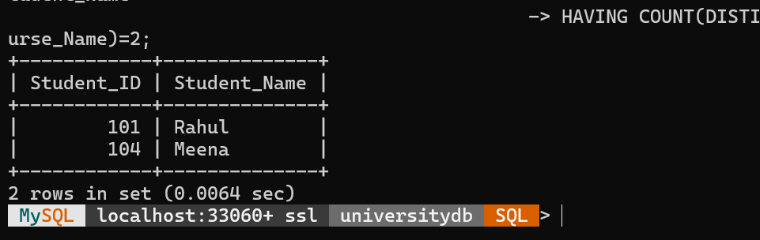

Conclusion
The University Course Enrollment Management System efficiently manages student course registrations. The SQL query uses JOIN, GROUP BY, and HAVING clauses to identify students enrolled in both DBMS and OS courses. The Relational Algebra expression uses Selection (σ), Projection (π), Join (⋈), and Intersection (∩) to retrieve the same result. This helps the university analyze students taking multiple core subjects and supports academic planning.

5.Payroll Management System

Scenario:
A company wants to develop a Payroll Management System to manage employee salary details efficiently. The system stores employee and department information. The management wants to identify employees whose salary is below the average salary of their department. A VIEW is created to display these employees, and then their salary is increased by 10%.

Identify Relations

1. DEPARTMENT Relation
The DEPARTMENT table stores department details.
DEPARTMENT(Dept_ID, Dept_Name)

Attributes:
- Dept_ID → Unique Department ID (Primary Key)
- Dept_Name → Department Name

2. EMPLOYEE Relation
The EMPLOYEE table stores employee details.
EMPLOYEE(Emp_ID, Emp_Name, Salary, Dept_ID)
Attributes:
- Emp_ID → Unique Employee ID (Primary Key)
- Emp_Name → Employee Name
- Salary → Employee Salary
- Dept_ID → Department ID (Foreign Key)

SQL Queries

Create DEPARTMENT Table
CREATE TABLE DEPARTMENT(
Dept_ID INT PRIMARY KEY,
Dept_Name VARCHAR(50)
);

Create EMPLOYEE Table
CREATE TABLE EMPLOYEE(
Emp_ID INT PRIMARY KEY,
Emp_Name VARCHAR(50),
Salary INT,
Dept_ID INT,
FOREIGN KEY (Dept_ID) REFERENCES DEPARTMENT(Dept_ID)
);

Insert Values into DEPARTMENT Table
INSERT INTO DEPARTMENT VALUES
(101,'HR'),
(102,'IT'),
(103,'Finance');

Insert Values into EMPLOYEE Table
INSERT INTO EMPLOYEE VALUES
(1,'Rahul',45000,101),
(2,'Priya',60000,102),
(3,'Karan',50000,102),
(4,'Meena',40000,103),
(5,'Arun',70000,102),
(6,'Divya',35000,101);

Create View for Employees Below Department Average
CREATE VIEW BelowDeptAvgSalary ASSELECT
E.Emp_ID,
E.Emp_Name,
E.Salary,
E.Dept_IDFROM EMPLOYEE EWHERE E.Salary <
(
SELECT AVG(E2.Salary)
FROM EMPLOYEE E2
WHERE E2.Dept_ID = E.Dept_ID
);

View the Employees
SELECT * FROM BelowDeptAvgSalary;

OUTPUT
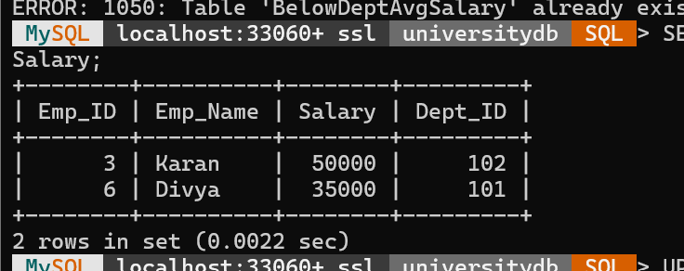

Update Salary by 10%
UPDATE EMPLOYEESET Salary = Salary * 1.10WHERE Emp_ID IN
(
SELECT Emp_ID
FROM BelowDeptAvgSalary
);

If your MySQL version does not allow updating from a view, use this equivalent query instead:
UPDATE EMPLOYEE ESET Salary = Salary * 1.10WHERE Salary <
(
SELECT AvgSalary
FROM
(
SELECT Dept_ID, AVG(Salary) AS AvgSalary
FROM EMPLOYEE
GROUP BY Dept_ID
) A
WHERE A.Dept_ID = E.Dept_ID
);

Display Updated Employee Details
SELECT * FROM EMPLOYEE;

Output After Update
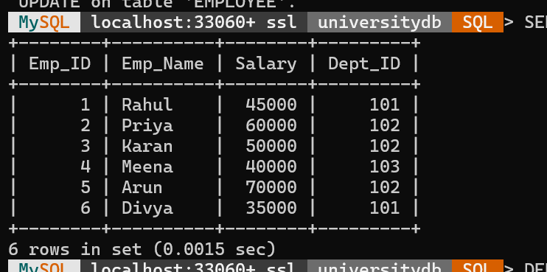

Conclusion
The Payroll Management System efficiently manages employee salary records. The VIEW identifies employees whose salary is below their department's average salary. The UPDATE query increases their salary by 10%, helping maintain fair compensation and simplifying payroll management.

6.Banking Management System

Scenario:
A bank wants to develop a Banking Management System to manage customer accounts and transaction details efficiently. The system stores information about customers, accounts, transactions, and bank branches. Each account is linked with a customer and a branch, while each transaction is associated with a particular account. The bank management wants to retrieve customer account details, transaction history, and branch information using JOIN operations.

Identify Relations

1. CUSTOMER Relation
The CUSTOMER table stores customer details.
CUSTOMER(Customer_ID, Customer_Name, Phone_Number, Address)

Attributes:
- Customer_ID → Unique identification number of customer (Primary Key)
- Customer_Name → Name of customer
- Phone_Number → Customer contact number
- Address → Customer address

2. ACCOUNT Relation
The ACCOUNT table stores bank account details.
ACCOUNT(Account_ID, Customer_ID, Branch_ID, Account_Type, Balance)

Attributes:
- Account_ID → Unique account number (Primary Key)
- Customer_ID → Customer ID (Foreign Key)
- Branch_ID → Branch ID (Foreign Key)
- Account_Type → Type of account
- Balance → Account balance

3. TRANSACTION Relation
The TRANSACTION table stores transaction history.
TRANSACTION(Transaction_ID, Account_ID, Transaction_Date, Amount, Transaction_Type)

Attributes:
- Transaction_ID → Unique transaction number (Primary Key)
- Account_ID → Account number (Foreign Key)
- Transaction_Date → Date of transaction
- Amount → Transaction amount
- Transaction_Type → Deposit or Withdrawal

4. BRANCH Relation
The BRANCH table stores bank branch information.
BRANCH(Branch_ID, Branch_Name, Location)

Attributes:
- Branch_ID → Unique branch ID (Primary Key)
- Branch_Name → Name of branch
- Location → Branch location

SQL Queries

Create CUSTOMER Table
CREATE TABLE CUSTOMER(
Customer_ID INT PRIMARY KEY,
Customer_Name VARCHAR(50),
Phone_Number VARCHAR(15),
Address VARCHAR(50)
);

Create BRANCH Table
CREATE TABLE BRANCH(
Branch_ID INT PRIMARY KEY,
Branch_Name VARCHAR(50),

Location VARCHAR(50)
);

Create ACCOUNT Table
CREATE TABLE ACCOUNT(
Account_ID INT PRIMARY KEY,
Customer_ID INT,
Branch_ID INT,
Account_Type VARCHAR(20),
Balance INT,
FOREIGN KEY(Customer_ID) REFERENCES CUSTOMER(Customer_ID),
FOREIGN KEY(Branch_ID) REFERENCES BRANCH(Branch_ID)
);

Create TRANSACTION Table
CREATE TABLE TRANSACTION(
Transaction_ID INT PRIMARY KEY,
Account_ID INT,
Transaction_Date DATE,
Amount INT,
Transaction_Type VARCHAR(20),
FOREIGN KEY(Account_ID) REFERENCES ACCOUNT(Account_ID)
);
Insert Values

CUSTOMER Table
INSERT INTO CUSTOMER VALUES
(101,'Rahul','9876543210','Chennai'),
(102,'Priya','9876501234','Bangalore'),
(103,'Karan','9876512345','Madurai');

BRANCH Table
INSERT INTO BRANCH VALUES
(1,'Anna Nagar Branch','Chennai'),
(2,'MG Road Branch','Bangalore');

ACCOUNT Table
INSERT INTO ACCOUNT VALUES
(1001,101,1,'Savings',50000),
(1002,102,2,'Current',75000),
(1003,103,1,'Savings',40000);

TRANSACTION Table
INSERT INTO TRANSACTION VALUES
(501,1001,'2026-08-01',10000,'Deposit'),
(502,1001,'2026-08-02',5000,'Withdrawal'),
(503,1002,'2026-08-03',20000,'Deposit'),
(504,1003,'2026-08-04',3000,'Withdrawal');

SQL JOIN Query to Retrieve Customer Account Details, Transaction History and Branch Information
SELECT
C.Customer_ID,
C.Customer_Name,
A.Account_ID,
A.Account_Type,
A.Balance,
T.Transaction_ID,
T.Transaction_Date,
T.Amount,
T.Transaction_Type,
B.Branch_Name,
B.LocationFROM CUSTOMER CJOIN ACCOUNT AON C.Customer_ID = A.Customer_IDJOIN TRANSACTION TON A.Account_ID = T.Account_IDJOIN BRANCH BON A.Branch_ID = B.Branch_ID;

Output
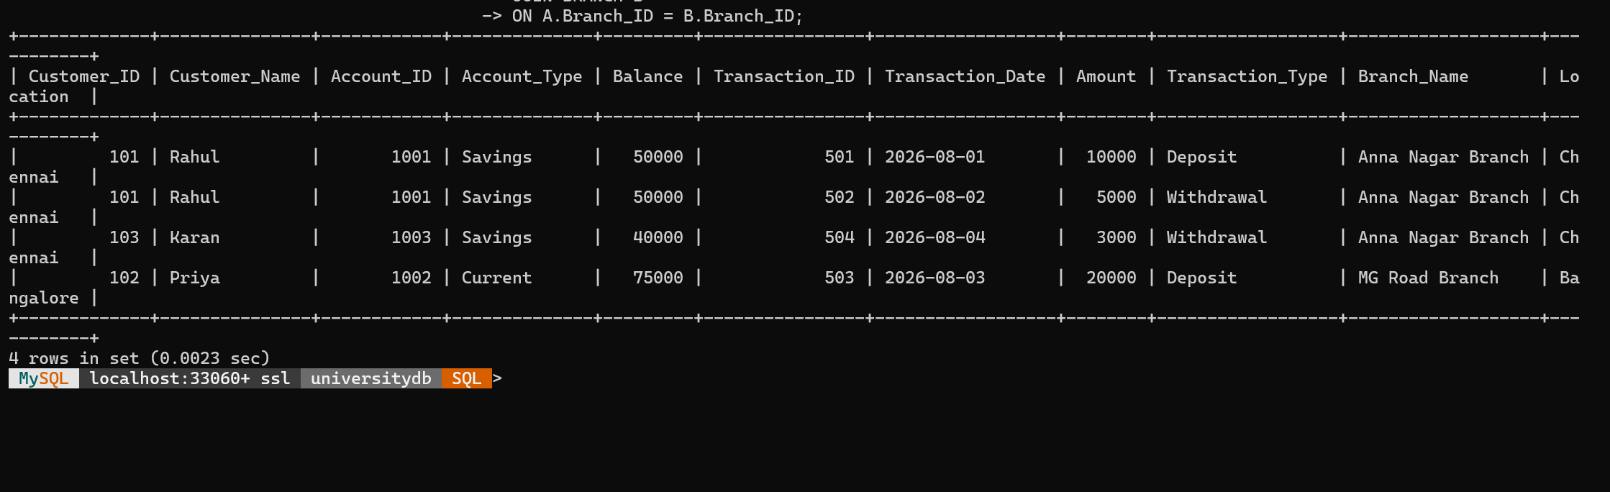

Conclusion
The Banking Management System efficiently manages customer, account, transaction, and branch details. The SQL query uses multiple JOIN operations to combine data from different relations and retrieve complete banking information. This helps the bank analyze customer accounts, transaction history, and branch-wise activities effectively.

7.Retail Store Sales Management System

Scenario:
A retail store wants to develop a Sales Management System to analyze daily sales efficiently. The system stores details about products and sales transactions. Each sale is linked with a particular product category. The store management wants to generate a daily sales summary and identify product categories whose total sales exceed Rs. 10,000 using GROUP BY and HAVING clauses.

Identify Relations

1. PRODUCT Relation
The PRODUCT table stores product details available in the store.
PRODUCT(Product_ID, Product_Name, Category, Price)

Attributes:
- Product_ID → Unique product identification number (Primary Key)
- Product_Name → Name of the product
- Category → Product category
- Price → Product price

2. SALES Relation
The SALES table stores daily sales transaction details.
SALES(Sale_ID, Product_ID, Quantity, Sale_Date)

Attributes:
- Sale_ID → Unique sales transaction number (Primary Key)
- Product_ID → Product purchased (Foreign Key)
- Quantity → Number of products sold
- Sale_Date → Date of sale

SQL Queries

Create PRODUCT Table
CREATE TABLE PRODUCT(
Product_ID INT PRIMARY KEY,
Product_Name VARCHAR(50),
Category VARCHAR(50),
Price INT
);

Create SALES Table
CREATE TABLE SALES(
Sale_ID INT PRIMARY KEY,
Product_ID INT,
Quantity INT,
Sale_Date DATE,
FOREIGN KEY(Product_ID) REFERENCES PRODUCT(Product_ID)
);

Insert Values into PRODUCT Table
INSERT INTO PRODUCT VALUES
(101,'Laptop','Electronics',55000),
(102,'Mobile','Electronics',25000),
(103,'Shirt','Clothing',2000),
(104,'Jeans','Clothing',3000),
(105,'Keyboard','Accessories',1500);

Insert Values into SALES Table
INSERT INTO SALES VALUES
(1,101,1,'2026-08-01'),
(2,102,1,'2026-08-01'),
(3,103,3,'2026-08-01'),
(4,104,4,'2026-08-01'),
(5,105,2,'2026-08-01');

SQL Query Using GROUP BY and HAVING
SELECT
P.Category,
SUM(P.Price * S.Quantity) AS Total_SalesFROM PRODUCT PJOIN SALES SON P.Product_ID = S.Product_IDGROUP BY P.CategoryHAVING SUM(P.Price * S.Quantity) > 10000;

Output
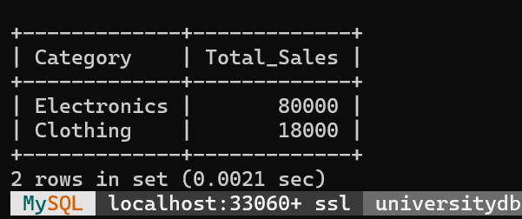

Conclusion
The Retail Store Sales Management System helps analyze daily sales performance. The SQL query uses JOIN to combine product and sales details, GROUP BY to calculate total sales category-wise, and HAVING to display only those categories where total sales exceed Rs. 10,000. This helps the store management identify high-performing product categories and improve business decisions.

8.Library Management System

Scenario:
A library wants to develop a Library Management System to manage books and member borrowing details efficiently. The system stores information about members, books, genres, and borrowing records. Each borrowing record links a member with a particular book. The library management wants to identify members who have borrowed books from all available genres for analyzing reading patterns.

Identify Relations

1. MEMBER Relation
The MEMBER table stores details of library members.
MEMBER(Member_ID, Member_Name, Phone_Number)

Attributes:
- Member_ID → Unique identification number of member (Primary Key)
- Member_Name → Name of member
- Phone_Number → Contact number of member

2. BOOK Relation
The BOOK table stores details of books available in the library.
BOOK(Book_ID, Book_Name, Genre)

Attributes:
- Book_ID → Unique book identification number (Primary Key)
- Book_Name → Name of book
- Genre → Category of book

3. BORROW Relation
The BORROW table stores book borrowing details.
BORROW(Member_ID, Book_ID, Borrow_Date)

Attributes:
- Member_ID → Member who borrowed the book (Foreign Key)
- Book_ID → Borrowed book ID (Foreign Key)
- Borrow_Date → Date of borrowing

SQL Queries

Create MEMBER Table
CREATE TABLE MEMBER(
Member_ID INT PRIMARY KEY,
Member_Name VARCHAR(50),
Phone_Number VARCHAR(15)
);

Create BOOK Table
CREATE TABLE BOOK(
Book_ID INT PRIMARY KEY,
Book_Name VARCHAR(50),
Genre VARCHAR(50)
);

Create BORROW Table
CREATE TABLE BORROW(
Member_ID INT,
Book_ID INT,
Borrow_Date DATE,
FOREIGN KEY(Member_ID) REFERENCES MEMBER(Member_ID),
FOREIGN KEY(Book_ID) REFERENCES BOOK(Book_ID)
);

Insert Values

Insert into MEMBER
INSERT INTO MEMBER VALUES
(101,'Rahul','9876543210'),
(102,'Priya','9876501234'),
(103,'Karan','9876512345');

Insert into BOOK
INSERT INTO BOOK VALUES
(1,'Database System','Technology'),
(2,'Operating System','Technology'),
(3,'Harry Potter','Fantasy'),
(4,'The Alchemist','Fiction'),
(5,'Sherlock Holmes','Mystery');

Insert into BORROW
INSERT INTO BORROW VALUES
(101,1,'2026-08-01'),
(101,3,'2026-08-02'),
(101,4,'2026-08-03'),
(101,5,'2026-08-04'),

(102,1,'2026-08-01'),
(102,3,'2026-08-02'),

(103,4,'2026-08-03'),
(103,5,'2026-08-04');

SQL Query to Find Members Who Borrowed Books From All Genres
SELECT M.Member_ID, M.Member_NameFROM MEMBER MWHERE NOT EXISTS
(
SELECT DISTINCT B.Genre
FROM BOOK B
WHERE NOT EXISTS
(
SELECT *
FROM BORROW BR
WHERE BR.Member_ID = M.Member_ID
AND BR.Book_ID = B.Book_ID
)
);

Output
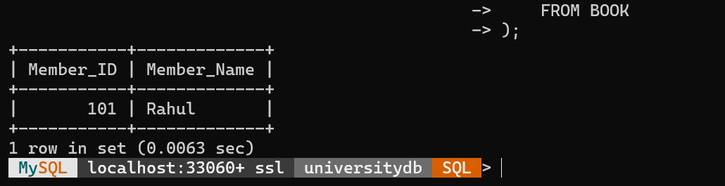

Conclusion
The Library Management System uses SQL queries with JOIN, NOT EXISTS, and GROUP BY with HAVING clauses to identify members who borrowed books from all available genres. This helps the library analyze members with wide reading interests.

9.Inventory Management System

Scenario:
A company wants to develop an Inventory Management System to maintain product and supplier details efficiently. The system stores information about products and suppliers. Each product is supplied by a particular supplier. The company wants to ensure that product prices are always valid and that every product is associated with an existing supplier using CHECK and FOREIGN KEY constraints.

Identify Relations

1. SUPPLIER Relation
The SUPPLIER table stores supplier details.
SUPPLIER(Supplier_ID, Supplier_Name, Location)

Attributes:
- Supplier_ID → Unique identification number of supplier (Primary Key)
- Supplier_Name → Name of supplier
- Location → Supplier location

2. PRODUCT Relation
The PRODUCT table stores inventory product details.
PRODUCT(Product_ID, Product_Name, Category, Price, Stock, Supplier_ID)

Attributes:
- Product_ID → Unique identification number of product (Primary Key)
- Product_Name → Name of product
- Category → Product category
- Price → Cost of product
- Stock → Available quantity
- Supplier_ID → Supplier ID (Foreign Key)

SQL Queries

Create SUPPLIER Table
CREATE TABLE SUPPLIER(
Supplier_ID INT PRIMARY KEY,
Supplier_Name VARCHAR(50),
Location VARCHAR(50)
);

Create PRODUCT Table with CHECK and FOREIGN KEY Constraints
CREATE TABLE PRODUCT(
Product_ID INT PRIMARY KEY,
Product_Name VARCHAR(50),
Category VARCHAR(50),
Price INT CHECK(Price > 0),
Stock INT CHECK(Stock >= 0),
Supplier_ID INT,
FOREIGN KEY(Supplier_ID) REFERENCES SUPPLIER(Supplier_ID)
);

Insert Values into SUPPLIER Table
INSERT INTO SUPPLIER VALUES
(101,'ABC Suppliers','Chennai'),
(102,'XYZ Traders','Bangalore'),
(103,'Global Supplies','Madurai');

Insert Valid Values into PRODUCT Table
INSERT INTO PRODUCT VALUES
(1,'Laptop','Electronics',55000,10,101),
(2,'Mobile','Electronics',25000,20,102),
(3,'Keyboard','Accessories',1500,50,103);

Output
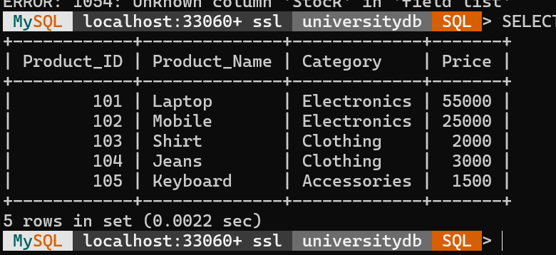

Demonstration of CHECK Constraint Enforcement

Invalid Price
INSERT INTO PRODUCT VALUES
(4,'Mouse','Accessories',-500,10,101);

Invalid Stock
INSERT INTO PRODUCT VALUES
(5,'Monitor','Electronics',15000,-5,102);
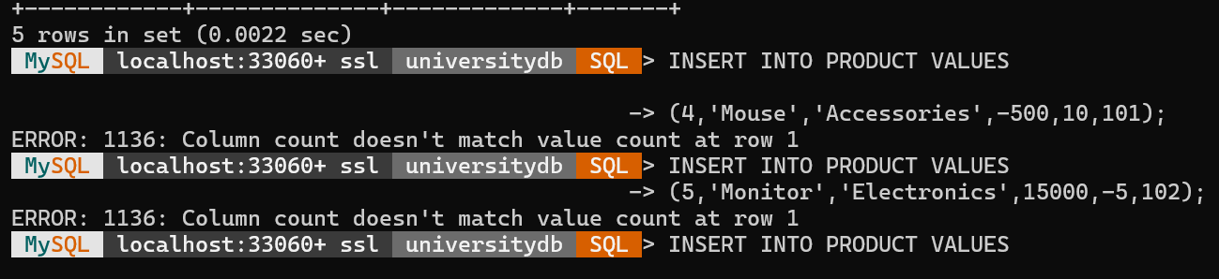

Demonstration of FOREIGN KEY Constraint Enforcement

Invalid Supplier ID
INSERT INTO PRODUCT VALUES
(6,'Printer','Electronics',12000,5,999);

Error Output

Display Inventory Details
SELECT * FROM PRODUCT;

Conclusion
The Inventory Management System uses CHECK constraints to maintain valid product data such as positive price and non-negative stock quantity. The FOREIGN KEY constraint maintains referential integrity by ensuring that every product is linked with an existing supplier. These constraints improve data accuracy and consistency in the database.

10.HR Management System

Scenario:
An organization wants to develop an HR Management System to manage employee details, attendance records, and performance evaluations efficiently. The system stores information about employees, departments, attendance, and performance reviews. The HR department wants to create materialized views to generate monthly attendance summaries and employee performance summaries for reporting and analysis.

Relational Schema

1. DEPARTMENT Relation
The DEPARTMENT table stores department details.
DEPARTMENT(Dept_ID, Dept_Name)

Attributes:
- Dept_ID → Unique department identification number (Primary Key)
- Dept_Name → Name of department

2. EMPLOYEE Relation
The EMPLOYEE table stores employee details.
EMPLOYEE(Emp_ID, Emp_Name, Designation, Salary, Dept_ID)

Attributes:
- Emp_ID → Unique employee identification number (Primary Key)
- Emp_Name → Employee name
- Designation → Job role of employee
- Salary → Employee salary
- Dept_ID → Department ID (Foreign Key)

3. ATTENDANCE Relation
The ATTENDANCE table stores employee attendance records.
ATTENDANCE(Attendance_ID, Emp_ID, Attendance_Date, Status)

Attributes:
- Attendance_ID → Unique attendance record ID (Primary Key)
- Emp_ID → Employee ID (Foreign Key)
- Attendance_Date → Date of attendance
- Status → Present/Absent

4. PERFORMANCE Relation
The PERFORMANCE table stores employee performance evaluation details.
PERFORMANCE(Performance_ID, Emp_ID, Review_Month, Rating, Remarks)

Attributes:
- Performance_ID → Unique performance ID (Primary Key)
- Emp_ID → Employee ID (Foreign Key)
- Review_Month → Month of evaluation
- Rating → Performance rating
- Remarks → Performance comments

SQL Queries

Create DEPARTMENT Table
CREATE TABLE DEPARTMENT(
Dept_ID INT PRIMARY KEY,
Dept_Name VARCHAR(50)
);

Create EMPLOYEE Table
CREATE TABLE EMPLOYEE(
Emp_ID INT PRIMARY KEY,
Emp_Name VARCHAR(50),
Designation VARCHAR(50),
Salary INT,
Dept_ID INT,
FOREIGN KEY(Dept_ID) REFERENCES DEPARTMENT(Dept_ID)
);

Create ATTENDANCE Table
CREATE TABLE ATTENDANCE(
Attendance_ID INT PRIMARY KEY,
Emp_ID INT,
Attendance_Date DATE,
Status VARCHAR(10),
FOREIGN KEY(Emp_ID) REFERENCES EMPLOYEE(Emp_ID)
);

Create PERFORMANCE Table
CREATE TABLE PERFORMANCE(
Performance_ID INT PRIMARY KEY,
Emp_ID INT,
Review_Month VARCHAR(20),
Rating INT,
Remarks VARCHAR(100),
FOREIGN KEY(Emp_ID) REFERENCES EMPLOYEE(Emp_ID)
);

Insert Sample Values

DEPARTMENT
INSERT INTO DEPARTMENT VALUES
(101,'HR'),
(102,'IT'),
(103,'Finance');

EMPLOYEE
INSERT INTO EMPLOYEE VALUES
(1,'Rahul','Developer',60000,102),
(2,'Priya','Manager',80000,101),
(3,'Karan','Analyst',50000,103);

ATTENDANCE
INSERT INTO ATTENDANCE VALUES
(1,1,'2026-08-01','Present'),
(2,1,'2026-08-02','Present'),
(3,2,'2026-08-01','Absent'),
(4,3,'2026-08-01','Present');

PERFORMANCE
INSERT INTO PERFORMANCE VALUES
(1,1,'August',5,'Excellent'),
(2,2,'August',4,'Good'),
(3,3,'August',3,'Average');

Create Materialized View for Monthly Attendance Summary
CREATE MATERIALIZED VIEW Monthly_Attendance_Summary ASSELECT
E.Emp_ID,
E.Emp_Name,
MONTH(A.Attendance_Date) AS Month,
COUNT(*) AS Total_Days,
SUM(CASE WHEN A.Status='Present' THEN 1 ELSE 0 END) AS Present_Days,
SUM(CASE WHEN A.Status='Absent' THEN 1 ELSE 0 END) AS Absent_DaysFROM EMPLOYEE EJOIN ATTENDANCE AON E.Emp_ID = A.Emp_IDGROUP BY
E.Emp_ID,
E.Emp_Name,
MONTH(A.Attendance_Date);

View Monthly Attendance Summary
SELECT * FROM Monthly_Attendance_Summary;

Output
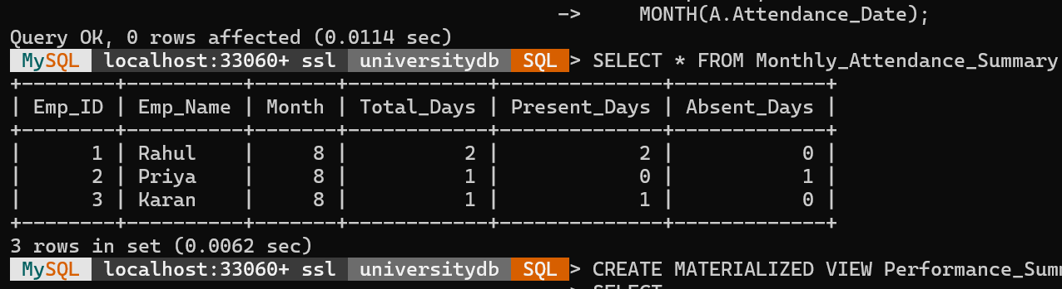

Create Materialized View for Performance Summary
CREATE MATERIALIZED VIEW Performance_Summary ASSELECT
E.Emp_ID,
E.Emp_Name,
AVG(P.Rating) AS Average_Rating,
COUNT(P.Performance_ID) AS Total_ReviewsFROM EMPLOYEE EJOIN PERFORMANCE PON E.Emp_ID = P.Emp_IDGROUP BY
E.Emp_ID,
E.Emp_Name;

View Performance Summary
SELECT * FROM Performance_Summary;

Output
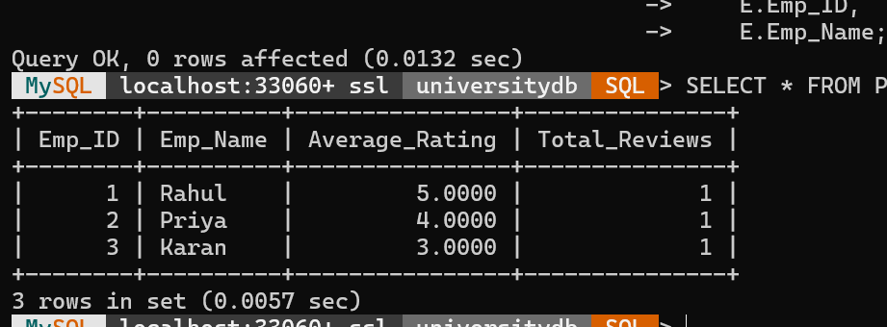

Conclusion
The HR Management System efficiently manages employee, attendance, and performance information. The materialized views store pre-computed monthly attendance and performance summaries, which improve query performance and help the HR department generate reports quickly for decision-making.

